1. Actors

1. Non-members

- Anyone who hasn’t made a membership

2. Members

- Can do everything a non-member can plus checkout books, and generally utilize the system

3. Associate

- An employee; assists users and uses the system to check books in, loan books out, etc.

4. Manager

- Can do everything a manager can plus is able to asses fines, create/delete employee accounts, and suspend/reactivate user accounts

2. Use Case Diagrams

1. Non-members

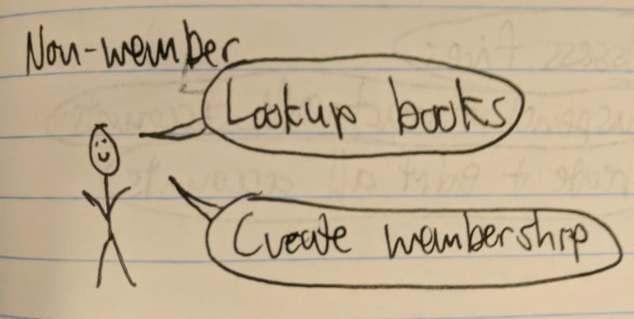

2. Members

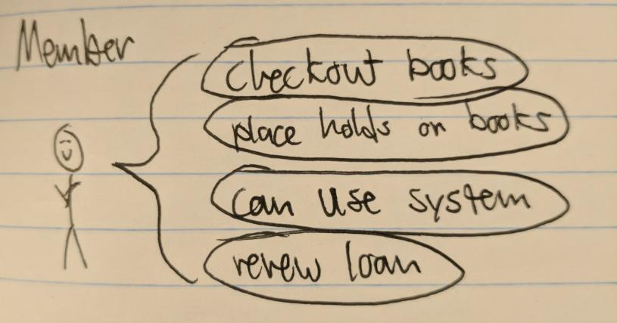

3. Associates & Managers

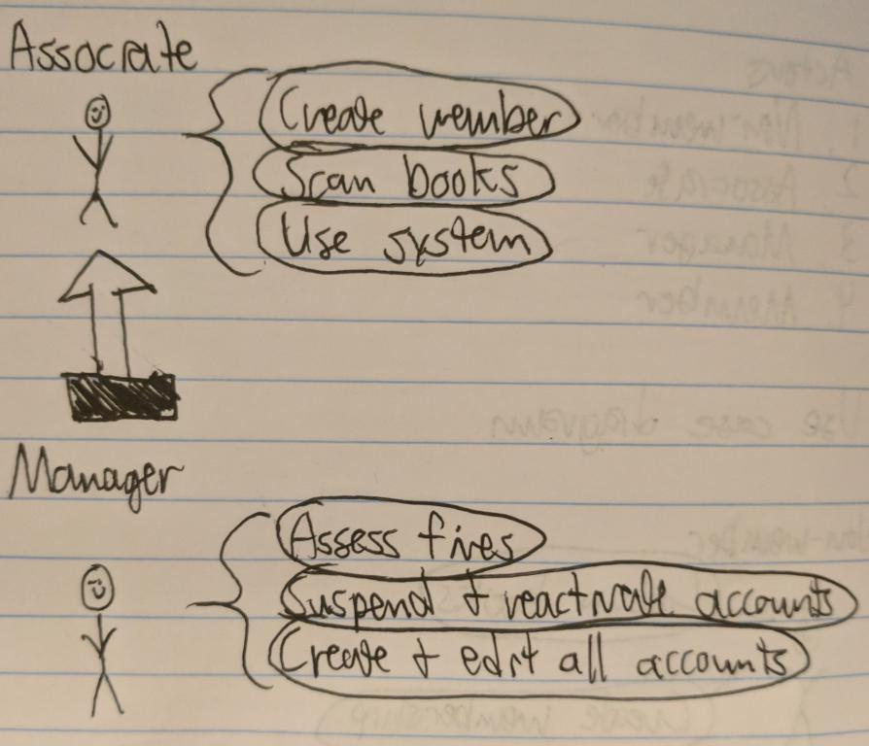

3. User Stories

US1: Search for Books

- A non-member can search for books to find books easier

Functionality / System requirements:

- A database of books

US2: Become a Member

- A non member can become a member to check out books

US3: Checkout Books

- A Member can check out books in order to read books

US4: Place Hold on Books

- A Member can place holds on books in order to reserve the books for 4 days.

US5: Renew Book Loans

- A Member can renew book loans in order to keep the book longer.

US6: Report Lost Books

- A member can report lost books so the library knows which books are missing

US7: Create a Member

- An Associate can create a member because the non-member asked

Functionality / System requirements:

- A database of users

US8: Scan a Book

- An Associate can scan a book in order to check it out

US9: Create/Delete Employee Accounts

- A Manager can create / delete employee accounts so they can manage them better

Functionality / System requirements:

- Database for employees

US10: Asses Fines

- A manager can asses fines to know whose account to suspend

US11: Suspend/Reactivate Accounts

- A manager can suspend / reactivate accounts in order to limit members who have overdue accounts

4. User Story Prioritization & Size Estimates

US ID Title Priority Size (Story Points)

US3 Checkout Books 1 3

US2 Become a Member 2 1

US7 Create a Member 2 1

US1 Search for Books 3 2

US8 Scan a Book 4 2

US5 Renew Book Loans 5 2

US9 Create/Delete Employee Accounts 6 5

US10 Asses Fines 7 8

US11 Suspend/Reactivate Accounts 8 3

US6 Report Lost Books 9 2

US4 Place Hold on Books 10 2

Our User Stories are prioritized based on the level of estimated importance of each to the system. For instance, searching for books is one of the core functionalities that the system has to perform since every user is able to do it and forms the basis of a catalog system. We have placed becoming a member and creating a member at the same level because one cannot happen without the other.

We used Fibonacci numbers for our story points. The difference in points between assessing fines and becoming a member for instance are so large because we expect that creating a member is pretty basic. It is just basically adding a database entry. Assessing fines is much more involve because it requires looking up the member, viewing books they have checked out, and then placing the fine. It is more of an involved process.